**ACCOUNT: OMD RUSSIA**

**SITE: WAS SUBMITTED IN GA TEMPLATE DOC – THEY ARE AN AGENCY**

**COMPLAINT: Summarized Skype chat below.**

[8/30/2017 5:20:02 PM] Marina Koroleva: We have really strange split between desktop and mobile traffic. We’ve made an analysis for painkillers category and it wasn’t look well, so we checked it with previous analysis we’d made for previous strategy

[8/30/2017 5:20:19 PM] Marina Koroleva: And the results we’ve got are different

[8/30/2017 5:21:24 PM] Marina Koroleva: Why is this possible? Is there any problems with SimilarWeb functioning?

[8/30/2017 5:21:46 PM] Mariel Ackerman (SimilarWeb): Good question. This month, we made some changes to our mobile web algorithm to increase the accuracy of the data - so there is a change that the values could have changed since the past.

[8/30/2017 5:23:37 PM] Marina Koroleva: But it works incorrectly

[8/30/2017 5:24:11 PM] Marina Koroleva: Because we’ve compared it with Google Analytics

[8/30/2017 5:28:43 PM] Mariel Ackerman (SimilarWeb): Okay. So can you please send me an Excel with the website and GA data for that domain on desktop and mobile and tablet for the past 3 months - this way I can open an investigation with the research team.

[8/30/2017 6:06:15 PM] Marina Koroleva: Thanks! And when could you answer me about correct data? We have an urgent analysis for two strategies

[8/31/2017 5:32:17 PM] Mariel Ackerman (SimilarWeb): and For which domain is this?

[8/31/2017 5:33:58 PM] Marina Koroleva: It’s for http://www.nextpainkiller.ru/

[9/1/2017 11:34:56 AM] Marina Koroleva: Hi, Mariel, thanks. It’s possible, but it’s not correct for brands we’ve analysed in the past. And we know, that previous split was correct more or less

[9/1/2017 11:35:26 AM] Marina Koroleva: And now we can’t use devices data, because it’s incorrect

[9/1/2017 11:47:01 AM] Marina Koroleva: Now we’re working with pharmaceutical category and all of them has small sites

[9/1/2017 12:01:12 PM] Marina Koroleva: And I also see really strange dynamic in traffic

[9/1/2017 12:01:36 PM] Marina Koroleva: For example

[9/1/2017 12:03:07 PM] Marina Koroleva: It’s not possible, when traffic in June is 116 visits and in July it’s 22765 vists

[9/1/2017 12:40:53 PM] Mariel Ackerman (SimilarWeb): Right, I understand.

[9/1/2017 12:43:41 PM] Marina Koroleva: Is it possible to fix this? Because I can’t make an analysis and I have plenty of urgent projects :(

**ACCOUNT: TELEFONICA CHILE**

**SITE: MOVISTAR.CL**

**COMPLAINT:**

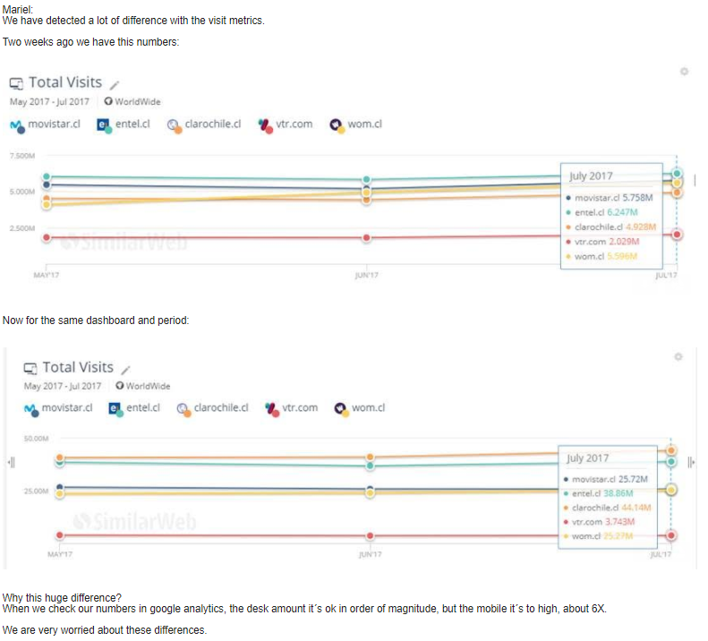



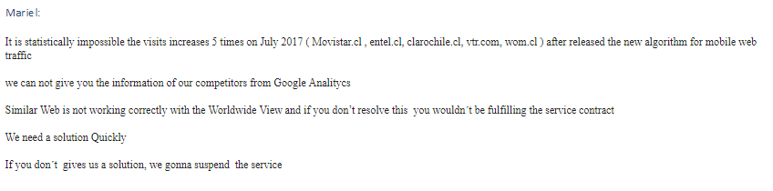

**ACCOUNT: EL COMERCIO**

**SITE: SEE BELOW**

**COMPLAINT: SEE BELOW**

Buenos días Mariel,

Te saluda Gonzalo Reátegui, Gerente de MKT de la Unidad de Negocios Transaccionales del Grupo el Comercio. Mariel, quería consultarte, [Bumeran.com.pe](http://bumeran.com.pe/) ha modificado algo dentro de su plataforma, ya que hemos estado analizando mes a mes su tráfico, y hemos visto que este ha variado enormemente.

Hemos visto que en Similarweb, su tráfico se ha incrementado casi en 100%, y esto de un momento a otro, y ha sido retroactivo para los meses anteriores. Mes a mes veníamos comparando el tráfico con Aptitus.com, y estábamos bastante cerca, y de un momento a otro, esto dejó de ser así.

Tú crees, que me puedas ayudar con esta consulta.

Muchas gracias!

**ACCOUNT: MEDIA24 – NASPERS**

**SITE: SPREE.CO.ZA**

**COMPLAINT:**

We compare our ([Spree.co.za](http://spree.co.za/)) Data (GA data) to those of our 2 major competitors - [Zando.co.za](http://zando.co.za/) and Superbalist.com

As of today their visits numbers are a lot higher than they were last week. This goes back 24 months. It looks like the mobile web numbers have been drastically adjusted upwards. We really would like to understand why.

Has there been a change to the Similarweb mobile traffic algorithm?

Looking at the last 24 months our Spree Similarweb numbers for Mobile web you show 22.8M but our actual GA number are 17.3M Your numbers are overstated on mobile web by close to 32% across all 3 businesses. Refer to screenshots. This presents a major problem for our us.

Please can you urgently confirm this is the case, as we need to be able to explain the sudden change in all the graphs we use for establishing our market positioning to our Board.

Regards,

Jonathan

Hi, I noticed a severe change in the traffic estimation between June and July. For a few of the websites I checked I have inside information on the real numbers and they are half or less than your estimation. For example:   
- Lazada.co.id - Estimation 93 million; real number under 50 million   
- PobPad.com - Estimation 3.46 million; real number 2.2 million   
- medthai.com - Estimation 9.9 million; real number 5 million (jumped from 3.5 million estimation in June)   
same jump noticed for haamor.com (real traffic <3M), lazada.co.th, and many others

The numbers were indeed understated in your previous algorithm, but they are seriously overstated now, to the extent that for lazada.co.id the number is impossibly high in a country with 60 million internet users. It would mean that each user in the country would check Lazada(which is an ecommerce, not a newspaper) on a monthly basis more than once or that a significant part of the country would visit it daily. Their marketing team could go home if this was true :)